Data report

TABLE OF CONTENTS

1.CHAPTER 1- Introduction

2. CHAPTER 2-Body

3. CHAPTER 3-Conclusion(s)/Discussion

4.CHAPTER 4- Appendix/Appendices

Now let’s consider the basic outline of the data analysis report in more detail:

1. Introduction. Good features for the Introduction include:

• Summary of the study and data, as well as any relevant substantive context, background, or framing issues.

• The “big questions” answered by your data analyses, and summaries of your conclusions about these questions.

• Brief outline of remainder of paper. The above is a pretty good order to present this material in as well.

2. Body. The body can be organized in several ways. Here are two that often work well: • Traditional. Divide the body up into several sections at the same level as the Introduction, with names like: – Data – Methods – Analysis – Results This format is very familiar to those who have written psych research papers. It often works well for a data analysis paper as well, though one problem with it is that the Methods section often sounds like a bit of a stretch: In a psych research paper the Methods section describes what you did to get your data. In a data analysis paper, you should describe the analyses that you performed. Without the results as well, this can be pretty sterile sounding, so I often merge these “methods” pieces into the “Analysis” section when I write. • Question-oriented. In this format there is a single Body section, usually called “Analysis”, and then there is a subsection for each question raised in the introduction, usually taken in the same order as in the introduction (general to specific, decreasing order of importance, etc.). Within each subsection, statistical method, analyses, and conclusion would be described (for each question). For example: 2. Analysis 2.1 Success Rate Methods Analysis Conclusions 2.2 Time to Relapse Methods Analysis Conclusions 3 2.3 Effect of Gender Methods Analysis Conclusions 2.4 Hospital Effects Methods Analysis Conclusions Etc. . . Other organizational formats are possible too. Whatever the format, it is useful to provide one or two well-chosen tables or graphs per question in the body of the report, for two reasons: First, graphical and tabular displays can convey your points more efficiently than words; and second, your “skimming” audiences will be more likely to have their eye caught by an interesting graph or table than by running text. However, too much graphical/tabular material will break up the flow of the text and become distracting; so extras should be moved to the Appendix. 3. Conclusion(s)/Discussion. The conclusion should reprise the questions and conclusions of the introduction, perhaps augmented by some additional observations or details gleaned from the analysis section. New questions, future work, etc., can also be raised here.

4. Appendix/Appendices. One or more appendices are the place to out details and ancillary materials. These might include such items as

• Technical descriptions of (unusual) statistical procedures

• Detailed tables or computer output

• Figures that were not central to the arguments presented in the body of the report



CHAPTER 1

|  |  |  |  |  |  |
| --- | --- | --- | --- | --- | --- |
|  | **EU Superstore: Statements of Financial Position** | | | |  |
|  | |  |  |  |  |
|  | |  |  |  |  |
|  | |  |  |  |  |
|  | |  |  |  |  |
|  | |  |  |  |  |
|  | | **31st December 2019** | **31st December 2018** | **31st December 2017** | **31st December 2016** |
| **Fixed Assets** | |  |  |  |  |
| Tangible Assets | | 9,387 | 9,016 | 8,906 | 8,450 |
| **Fixed Assets** | | **9,387** | **9,016** | **8,906** | **8,450** |
|  |  |  |  |  |  |
| **Current Assets** | |  |  |  |  |
| Stock | | 139,052 | 125,444 | 115,372 | 114,140 |
| Trade Debtors | | 30,159 | 23,809 | 18,080 | 12,747 |
| Bank & Deposits | | 34339 | 13295 | 13,257 |  |
| **Current Assets** | | **203,550** | **162,548** | **146,709** | **126,887** |
|  |  |  |  |  |  |
| **Total Assets** | | **212,937** | **171,564** | **155,615** | **135,337** |
|  |  |  |  |  |  |
|  |  |  |  |  |  |
| **Shareholders funds** | |  |  |  |  |
| Issued capital | | 60,000 | 60,000 | 60,000 | 60,000 |
| Retained profit | | 26,832 | 5,984 | -6,078 | -27,079 |
| **Total shareholders funds** | | **86,832** | **65,984** | **53,922** | **32,921** |
|  |  |  |  |  |  |
|  |  |  |  |  |  |
| **Long term liabilities** | |  |  |  |  |
| Long term debt | | 50,000 | 50,000 | 50,000 | 50,000 |
| **Total long term liabilities** | | **50,000** | **50,000** | **50,000** | **50,000** |
|  |  |  |  |  |  |
|  |  |  |  |  |  |
| **Current Liabilities** | |  |  |  |  |
| Trade Creditors | | 76,105 | 55,580 | 51,693 | 41,642 |
| Short Term Loans & Overdrafts | |  |  |  | 10,774 |
| **Total Current Liabilities** | | **76,105** | **55,580** | **51,693** | **52,416** |
|  |  |  |  |  |  |
| **Total liabilities** | | **212,937** | **171,564** | **155,615** | **135,337** |
|  |  |  |  |  |  |

|  |  |  |  |  |  |
| --- | --- | --- | --- | --- | --- |
|  | **EU Superstore: Statements of Financial Position** | | | |  |
|  | |  |  |  |  |
|  | |  |  |  |  |
|  | |  |  |  |  |
|  | |  |  |  |  |
|  | |  |  |  |  |
|  | | **31st December 2019** | **31st December 2018** | **31st December 2017** | **31st December 2016** |
| **Fixed Assets** | |  |  |  |  |
| Tangible Assets | | 9,387 | 9,016 | 8,906 | 8,450 |
| **Fixed Assets** | | **9,387** | **9,016** | **8,906** | **8,450** |
|  |  |  |  |  |  |
| **Current Assets** | |  |  |  |  |
| Stock | | 139,052 | 125,444 | 115,372 | 114,140 |
| Trade Debtors | | 30,159 | 23,809 | 18,080 | 12,747 |
| Bank & Deposits | | 34339 | 13295 | 13,257 |  |
| **Current Assets** | | **203,550** | **162,548** | **146,709** | **126,887** |
|  |  |  |  |  |  |
| **Total Assets** | | **212,937** | **171,564** | **155,615** | **135,337** |
|  |  |  |  |  |  |
|  |  |  |  |  |  |
| **Shareholders funds** | |  |  |  |  |
| Issued capital | | 60,000 | 60,000 | 60,000 | 60,000 |
| Retained profit | | 26,832 | 5,984 | -6,078 | -27,079 |
| **Total shareholders funds** | | **86,832** | **65,984** | **53,922** | **32,921** |
|  |  |  |  |  |  |
|  |  |  |  |  |  |
| **Long term liabilities** | |  |  |  |  |
| Long term debt | | 50,000 | 50,000 | 50,000 | 50,000 |
| **Total long term liabilities** | | **50,000** | **50,000** | **50,000** | **50,000** |
|  |  |  |  |  |  |
|  |  |  |  |  |  |
| **Current Liabilities** | |  |  |  |  |
| Trade Creditors | | 76,105 | 55,580 | 51,693 | 41,642 |
| Short Term Loans & Overdrafts | |  |  |  | 10,774 |
| **Total Current Liabilities** | | **76,105** | **55,580** | **51,693** | **52,416** |
|  |  |  |  |  |  |
| **Total liabilities** | | **212,937** | **171,564** | **155,615** | **135,337** |
|  |  |  |  |  |  |

CHAPTER 2

Sales and Profit

|  |  |  |  |  |  |  |  |  |  |
| --- | --- | --- | --- | --- | --- | --- | --- | --- | --- |
| **Two Sample t-test for Population Means - Sigmas Unknown- Raw Data** | | | |  |  |  | Sales | Profit |  |
| **1. Enter Data on blue cells only.** | |  |  |  |  |  | 79.2 | 39.6 |  |
| **Sample 1 mean x̅1 =** | 293.809 |  |  |  |  |  | 388.92 | 0 |  |
| **Sample 2 mean x̅2 =** | 37.283 |  |  |  |  |  | 35.19 | 16.11 |  |
| **Sample 1 Standard Dev. s1 =** | 486.056 |  |  |  |  |  | 50.94 | 13.2 |  |
| **Sample 2 Standard Dev. s2 =** | 178.100 |  |  |  |  |  | 307.44 | 73.71 |  |
| **Sample 1 size n1 =** | 10000 |  |  | **Do not delete or copy over the intermediate calculations.** | |  | 122.4 | 37.92 |  |
| **Sample 2 size n2 =** | 10000 |  |  |  | 413.82 | 20.61 |  |
| **Mean Difference Md = µ1 -µ2** | 0 | Confidence Level (1-α) |  | **Intermediate Calculations** | |  | 428.22 | 192.69 |  |
| **Significance Level α** | 0.050 | 95.0% |  | **Variances** | **S.E.** |  | 3979.29 | 1989.54 |  |
|  |  |  |  | **= Equal** | **5.176580208** |  | 43.56 | 12.6 |  |
| **2. Select Variance** | |  |  | **≠ Not Equal** | **5.176580208** |  | 25.26 | 0.48 |  |
| **Variances σ2 are** | **≠ Not Equal** | << click orange cell B 13 to Use drop down menu | | |  |  | 2443.905 | 760.305 |  |
| **Degrees of Freedom d.f.** | **9999.000** |  |  |  |  |  | 12.21 | 0 |  |
| **Test Statistic, Standardized Test Statistic** | |  |  |  |  |  | 2167.296 | 790.416 |  |
| |  | | --- | | **Test Statistic μ1 - μ2 =** | | **256.525932** |  |  |  |  |  | 138.105 | -12.345 |  |
| **Standard Error** | **5.1766** |  |  |  |  |  | 128.385 | 4.275 |  |
| **Standardized Test Statistic t =** | **49.55510** |  |  |  |  |  | 690.12 | 0 |  |
|  |  |  |  |  |  |  | 8.16 | 1.14 |  |
| **Two-Tail Test** | |  |  |  |  |  | 128.34 | 0 |  |
| **Lower Critical Value** | **-1.9602** |  |  |  |  |  | 11.82 | 1.02 |  |
| **Upper Critical Value** | **1.9602** |  |  |  |  |  | 14.04 | 7.02 |  |
| ***p*-Value** | **0.00000** |  |  |  |  |  | 268.164 | 5.904 |  |
|  |  |  |  |  |  |  | 36.72 | -5.52 |  |
| **Left-Tail Test** | |  | |  |  |  | 28.17 | 1.11 |  |
| **Lower Critical Value** | **-1.6450** |  |  |  |  |  | 279.72 | -6.33 |  |
| ***p*-Value** | **1.00000** |  |  |  |  |  | 108.78 | 35.7 |  |
|  |  |  |  |  |  |  | 332.01 | 112.77 |  |
| **Right-Tail Test** | |  |  |  |  |  | 110.025 | -12.225 |  |
| **Upper Critical Value** | **1.6450** |  |  |  |  |  | 41.94 | 7.92 |  |
| ***p*-Value** | **0.00000** |  |  |  |  |  | 1050.732 | 315.072 |  |

DISCOUNT AND PROFIT DATA

|  |  |  |  |  |  |  |  |  |  |  |
| --- | --- | --- | --- | --- | --- | --- | --- | --- | --- | --- |
| **Two Sample t-test for Population Means - Sigmas Unknown- Raw Data** | | | |  |  |  | Discount | Profit |  |  |
| **1. Enter Data on blue cells only.** | |  |  |  |  |  | 0 | 39.6 |  |  |
| **Sample 1 mean x̅1 =** | 0.103 |  |  |  |  |  | 0 | 0 |  |  |
| **Sample 2 mean x̅2 =** | 37.283 |  |  |  |  |  | 0 | 16.11 |  |  |
| **Sample 1 Standard Dev. s1 =** | 0.175 |  |  |  |  |  | 0 | 13.2 |  |  |
| **Sample 2 Standard Dev. s2 =** | 178.100 |  |  |  |  |  | 0 | 73.71 |  |  |
| **Sample 1 size n1 =** | 10000 |  |  | **Do not delete or copy over the intermediate calculations.** | |  | 0 | 37.92 |  |  |
| **Sample 2 size n2 =** | 10000 |  |  |  | 0 | 20.61 |  |  |
| **Mean Difference Md = µ1 -µ2** | 0 | Confidence Level (1-α) |  | **Intermediate Calculations** | |  | 0 | 192.69 |  |  |
| **Significance Level α** | 0.050 | 95.0% |  | **Variances** | **S.E.** |  | 0 | 1989.54 |  |  |
|  |  |  |  | **= Equal** | **1.781004694** |  | 0 | 12.6 |  |  |
| **2. Select Variance** | |  |  | **≠ Not Equal** | **1.781004694** |  | 0 | 0.48 |  |  |
| **Variances σ2 are** | **≠ Not Equal** | << click orange cell B 13 to Use drop down menu | | |  |  | 0.1 | 760.305 |  |  |
| **Degrees of Freedom d.f.** | **9999.000** |  |  |  |  |  | 0 | 0 |  |  |
| **Test Statistic, Standardized Test Statistic** | |  |  |  |  |  | 0.15 | 790.416 |  |  |
| |  | | --- | | **Test Statistic μ1 - μ2 =** | | **-37.17986915** |  |  |  |  |  | 0.1 | -12.345 |  |  |
| **Standard Error** | **1.7810** |  |  |  |  |  | 0.1 | 4.275 |  |  |
| **Standardized Test Statistic t =** | **-20.87578** |  |  |  |  |  | 0 | 0 |  |  |
|  |  |  |  |  |  |  | 0 | 1.14 |  |  |
| **Two-Tail Test** | |  |  |  |  |  | 0 | 0 |  |  |
| **Lower Critical Value** | **-1.9602** |  |  |  |  |  | 0 | 1.02 |  |  |
| **Upper Critical Value** | **1.9602** |  |  |  |  |  | 0 | 7.02 |  |  |
| ***p*-Value** | **0.00000** |  |  |  |  |  | 0.1 | 5.904 |  |  |
|  |  |  |  |  |  |  | 0.4 | -5.52 |  |  |
| **Left-Tail Test** | |  | |  |  |  | 0 | 1.11 |  |  |
| **Lower Critical Value** | **-1.6450** |  |  |  |  |  | 0.1 | -6.33 |  |  |
| ***p*-Value** | **0.00000** |  |  |  |  |  | 0 | 35.7 |  |  |
|  |  |  |  |  |  |  | 0 | 112.77 |  |  |
| **Right-Tail Test** | |  |  |  |  |  | 0.1 | -12.225 |  |  |
| **Upper Critical Value** | **1.6450** |  |  |  |  |  | 0 | 7.92 |  |  |
| ***p*-Value** | **1.00000** |  |  |  |  |  | 0.1 | 315.072 |  |  |
|  |  |  |  |  |  |  | 0 | 21.63 |  |  |
| **Copyright 2017/18/19 Dawn E Wright Ph.D.** | |  |  |  |  |  | 0 | 35.88 |  |  |
|  |  |  |  |  |  |  | 0 | 30.96 |  |  |
|  |  |  |  |  |  |  | 0 | 8.34 |  |  |
|  |  |  |  |  |  |  | 0 | 25.11 |  |  |
|  |  |  |  |  |  |  | 0 | 23.31 |  |  |
|  |  |  |  |  |  |  | 0.1 | 8.07 |  |  |
|  |  |  |  |  |  |  | 0 | 8.91 |  |  |
|  |  |  |  |  |  |  | 0 | 15.3 |  |  |

Sales Data

|  |  |  |  |  |
| --- | --- | --- | --- | --- |
| **One-sample Z Test Population Mean** | |  | Sales |  |
| Enter data in blue cells only |  |  | 79.2 |  |
| **Data** | |  | 388.92 |  |
| **Null Hypothesis =** | **12.0000** |  | 35.19 |  |
| **Level of Significance Alpha α** | **0.010** |  | 50.94 |  |
| **Population Standard Deviation** | **28580.7590** |  | 307.44 |  |
| **Sample Size** | **10000** |  | 122.4 |  |
| **Sample Mean** | **293.8089** |  | 413.82 |  |
|  |  |  | 428.22 |  |
| **Intermediate Calculations** | |  | 3979.29 |  |
| Standard Error of the Mean | **285.8076** |  | 43.56 |  |
| ***Z* Test Statistic** | **0.9860** |  | 25.26 |  |
|  |  |  | 2443.905 |  |
| **Two-Tail Test** | |  | 12.21 |  |
| **Lower Critical Value** | **-2.5758** |  | 2167.296 |  |
| **Upper Critical Value** | **2.5758** |  | 138.105 |  |
| ***p*-Value** | **0.3241** |  | 128.385 |  |
|  |  |  | 690.12 |  |
| **Left-Tail Test** | |  | 8.16 |  |
| **Lower Critical Value** | **-2.3263** |  | 128.34 |  |
| ***p*-Value** | **0.8379** |  | 11.82 |  |
|  |  |  | 14.04 |  |
| **Right-Tail Test** | |  | 268.164 |  |
| **Upper Critical Value** | **2.3263** |  | 36.72 |  |
| ***p*-Value** | **0.1621** |  | 28.17 |  |
|  |  |  | 279.72 |  |
| **Copyright 2017/18/19 Dawn E Wright Ph.D.** | |  | 108.78 |  |
|  |  |  | 332.01 |  |
|  |  |  | 110.025 |  |
|  |  |  | 41.94 |  |
|  |  |  | 1050.732 |  |
|  |  |  | 58.59 |  |
|  |  |  | 102.54 |  |

PROFIT DATA

|  |  |  |  |  |
| --- | --- | --- | --- | --- |
| **One-sample Z Test Population Mean** | |  | Profit |  |
| Enter data in blue cells only |  |  | 39.6 |  |
| **Data** | |  | 0 |  |
| **Null Hypothesis =** | **12.0000** |  | 16.11 |  |
| **Level of Significance Alpha α** | **0.010** |  | 13.2 |  |
| **Population Standard Deviation** | **28580.7590** |  | 73.71 |  |
| **Sample Size** | **10000** |  | 37.92 |  |
| **Sample Mean** | **37.2830** |  | 20.61 |  |
|  |  |  | 192.69 |  |
| **Intermediate Calculations** | |  | 1989.54 |  |
| Standard Error of the Mean | **285.8076** |  | 12.6 |  |
| ***Z* Test Statistic** | **0.0885** |  | 0.48 |  |
|  |  |  | 760.305 |  |
| **Two-Tail Test** | |  | 0 |  |
| **Lower Critical Value** | **-2.5758** |  | 790.416 |  |
| **Upper Critical Value** | **2.5758** |  | -12.345 |  |
| ***p*-Value** | **0.9295** |  | 4.275 |  |
|  |  |  | 0 |  |
| **Left-Tail Test** | |  | 1.14 |  |
| **Lower Critical Value** | **-2.3263** |  | 0 |  |
| ***p*-Value** | **0.5352** |  | 1.02 |  |
|  |  |  | 7.02 |  |
| **Right-Tail Test** | |  | 5.904 |  |
| **Upper Critical Value** | **2.3263** |  | -5.52 |  |
| ***p*-Value** | **0.4648** |  | 1.11 |  |
|  |  |  | -6.33 |  |
| **Copyright 2017/18/19 Dawn E Wright Ph.D.** | |  | 35.7 |  |
|  |  |  | 112.77 |  |
|  |  |  | -12.225 |  |
|  |  |  | 7.92 |  |
|  |  |  | 315.072 |  |
|  |  |  | 21.63 |  |

TWO SAMPLE T-TEST FOR POPULATION MEANS

|  |  |  |  |  |  |  |  |  |  |  |
| --- | --- | --- | --- | --- | --- | --- | --- | --- | --- | --- |
| **Two Sample t-test for Population Means - Sigmas Unknown- Raw Data** | | | |  |  |  |  | Sales | Profit |  |
| **1. Enter Data on blue cells only.** | |  |  |  |  |  |  | 79.2 | 39.6 |  |
| **Sample 1 mean x̅1 =** | 293.809 |  |  |  |  |  |  | 388.92 | 0 |  |
| **Sample 2 mean x̅2 =** | 37.283 |  |  |  |  |  |  | 35.19 | 16.11 |  |
| **Sample 1 Standard Dev. s1 =** | 486.056 |  |  |  |  |  |  | 50.94 | 13.2 |  |
| **Sample 2 Standard Dev. s2 =** | 178.100 |  |  |  |  |  |  | 307.44 | 73.71 |  |
| **Sample 1 size n1 =** | 10000 |  |  | **Do not delete or copy over the intermediate calculations.** | |  |  | 122.4 | 37.92 |  |
| **Sample 2 size n2 =** | 10000 |  |  |  |  | 413.82 | 20.61 |  |
| **Mean Difference Md = µ1 -µ2** | 0 | Confidence Level (1-α) |  | **Intermediate Calculations** | |  |  | 428.22 | 192.69 |  |
| **Significance Level α** | 0.050 | 95.0% |  | **Variances** | **S.E.** |  |  | 3979.29 | 1989.54 |  |
|  |  |  |  | **= Equal** | **5.176580208** |  |  | 43.56 | 12.6 |  |
| **2. Select Variance** | |  |  | **≠ Not Equal** | **5.176580208** |  |  | 25.26 | 0.48 |  |
| **Variances σ2 are** | **≠ Not Equal** | << click orange cell B 13 to Use drop down menu | | |  |  |  | 2443.905 | 760.305 |  |
| **Degrees of Freedom d.f.** | **9999.000** |  |  |  |  |  |  | 12.21 | 0 |  |
| **Test Statistic, Standardized Test Statistic** | |  |  |  |  |  |  | 2167.296 | 790.416 |  |
| |  | | --- | | **Test Statistic μ1 - μ2 =** | | **256.525932** |  |  |  |  |  |  | 138.105 | -12.345 |  |
| **Standard Error** | **5.1766** |  |  |  |  |  |  | 128.385 | 4.275 |  |
| **Standardized Test Statistic t =** | **49.55510** |  |  |  |  |  |  | 690.12 | 0 |  |
|  |  |  |  |  |  |  |  | 8.16 | 1.14 |  |
| **Two-Tail Test** | |  |  |  |  |  |  | 128.34 | 0 |  |
| **Lower Critical Value** | **-1.9602** |  |  |  |  |  |  | 11.82 | 1.02 |  |
| **Upper Critical Value** | **1.9602** |  |  |  |  |  |  | 14.04 | 7.02 |  |
| ***p*-Value** | **0.00000** |  |  |  |  |  |  | 268.164 | 5.904 |  |
|  |  |  |  |  |  |  |  | 36.72 | -5.52 |  |
| **Left-Tail Test** | |  | |  |  |  |  | 28.17 | 1.11 |  |
| **Lower Critical Value** | **-1.6450** |  |  |  |  |  |  | 279.72 | -6.33 |  |
| ***p*-Value** | **1.00000** |  |  |  |  |  |  | 108.78 | 35.7 |  |
|  |  |  |  |  |  |  |  | 332.01 | 112.77 |  |
| **Right-Tail Test** | |  |  |  |  |  |  | 110.025 | -12.225 |  |
| **Upper Critical Value** | **1.6450** |  |  |  |  |  |  | 41.94 | 7.92 |  |
| ***p*-Value** | **0.00000** |  |  |  |  |  |  | 1050.732 | 315.072 |  |
|  |  |  |  |  |  |  |  | 58.59 | 21.63 |  |
| **Copyright 2017/18/19 Dawn E Wright Ph.D.** | |  |  |  |  |  |  | 102.54 | 35.88 |  |
|  |  |  |  |  |  |  |  | 63.27 | 30.96 |  |
|  |  |  |  |  |  |  |  | 55.92 | 8.34 |  |
|  |  |  |  |  |  |  |  | 76.14 | 25.11 |  |

SALES AND QUANTITY

|  |  |  |  |  |  |  |  |  |
| --- | --- | --- | --- | --- | --- | --- | --- | --- |
| **Two Sample t-test for Population Means - Sigmas Unknown- Raw Data** | | | |  |  |  | Sales | Quantity |
| **1. Enter Data on blue cells only.** | |  |  |  |  |  | 79.2 | 3 |
| **Sample 1 mean x̅1 =** | 293.809 |  |  |  |  |  | 388.92 | 7 |
| **Sample 2 mean x̅2 =** | 3.777 |  |  |  |  |  | 35.19 | 3 |
| **Sample 1 Standard Dev. s1 =** | 486.056 |  |  |  |  |  | 50.94 | 2 |
| **Sample 2 Standard Dev. s2 =** | 2.203 |  |  |  |  |  | 307.44 | 3 |
| **Sample 1 size n1 =** | 10000 |  |  | **Do not delete or copy over the intermediate calculations.** | |  | 122.4 | 2 |
| **Sample 2 size n2 =** | 10000 |  |  |  | 413.82 | 3 |
| **Mean Difference Md = µ1 -µ2** | 0 | Confidence Level (1-α) |  | **Intermediate Calculations** | |  | 428.22 | 3 |
| **Significance Level α** | 0.050 | 95.0% |  | **Variances** | **S.E.** |  | 3979.29 | 7 |
|  |  |  |  | **= Equal** | **4.860606282** |  | 43.56 | 3 |
| **2. Select Variance** | |  |  | **≠ Not Equal** | **4.860606282** |  | 25.26 | 2 |
| **Variances σ2 are** | **≠ Not Equal** | << click orange cell B 13 to Use drop down menu | | |  |  | 2443.905 | 5 |
| **Degrees of Freedom d.f.** | **9999.000** |  |  |  |  |  | 12.21 | 1 |
| **Test Statistic, Standardized Test Statistic** | |  |  |  |  |  | 2167.296 | 4 |
| |  | | --- | | **Test Statistic μ1 - μ2 =** | | **290.0316062** |  |  |  |  |  | 138.105 | 5 |
| **Standard Error** | **4.8606** |  |  |  |  |  | 128.385 | 3 |
| **Standardized Test Statistic t =** | **59.66984** |  |  |  |  |  | 690.12 | 6 |
|  |  |  |  |  |  |  | 8.16 | 1 |
| **Two-Tail Test** | |  |  |  |  |  | 128.34 | 6 |
| **Lower Critical Value** | **-1.9602** |  |  |  |  |  | 11.82 | 2 |
| **Upper Critical Value** | **1.9602** |  |  |  |  |  | 14.04 | 2 |
| ***p*-Value** | **0.00000** |  |  |  |  |  | 268.164 | 2 |
|  |  |  |  |  |  |  | 36.72 | 1 |
| **Left-Tail Test** | |  | |  |  |  | 28.17 | 1 |
| **Lower Critical Value** | **-1.6450** |  |  |  |  |  | 279.72 | 5 |
| ***p*-Value** | **1.00000** |  |  |  |  |  | 108.78 | 7 |
|  |  |  |  |  |  |  | 332.01 | 7 |
| **Right-Tail Test** | |  |  |  |  |  | 110.025 | 5 |
| **Upper Critical Value** | **1.6450** |  |  |  |  |  | 41.94 | 3 |
| ***p*-Value** | **0.00000** |  |  |  |  |  | 1050.732 | 6 |
|  |  |  |  |  |  |  | 58.59 | 7 |
| **Copyright 2017/18/19 Dawn E Wright Ph.D.** | |  |  |  |  |  | 102.54 | 2 |
|  |  |  |  |  |  |  | 63.27 | 3 |
|  |  |  |  |  |  |  | 55.92 | 2 |

SALES DISTRIBUTION

QUANTITY DISTRIBUTION

PROFIT DISTRIBUTION

CHAPTER 3: CONCLUSIONS AND DISCUSSIONS

RATIO ANALYSIS FORMULAS

**What is the Ratio Analysis Formula?**

The term “Ratio Analysis” refers to the analytical technique wherein a plethora of financial ratios is computed based on the financial information either available in the annual reports or public domain. The ratio analysis helps in assessing the subject company’s financial and operational position.

The financial ratios used in ratio analysis technique are broadly categorized into the following four major categories:

* Liquidity Ratios
* Solvency Ratios
* Efficiency Ratios
* Profitability Ratios

**Explanation**

The formula for Ratio Analysis can be calculated by using the following steps:

**1. Liquidity Ratios**

These ratios indicate the company’s cash level, liquidity position and the capacity to meet its short-term liabilities. The formula of some of the major liquidity ratios are:

* **Current Ratio = Current Assets / Current Liabilities**
* **Quick Ratio = (Cash & Cash Equivalents + Accounts Receivables) / Current Liabilities**
* **Cash Ratio = Cash & Cash Equivalents / Current Liabilities**

**2. Solvency Ratios**

These ratios indicate whether the company has the capability to meet its long-term obligations by comparing its debt level with its assets and equity etc. The formula of some of the major solvency ratios are:

* **Debt-To-Equity Ratio = Total Debt / Total Equity**
* **Debt Ratio = Total Debt / Total Assets**
* **Interest Coverage Ratio = EBITDA / Interest Expense**

**3. Efficiency Ratios**

These ratios indicate how efficiently a company is able to utilize its available assets or convert its inventories to cash. The formula of some of the major efficiency ratios are:

 Popular Course in this category

**[Finance for Non Finance Managers Course (7 Courses)](https://www.educba.com/finance/courses/finance-for-non-finance-managers-course/?btnz=edu-blg-inline-banner1" \t "_blank)**[7 Online Courses | 25+ Hours | Verifiable Certificate of Completion | Lifetime Access  
4.5 (5,683 ratings)](https://www.educba.com/finance/courses/finance-for-non-finance-managers-course/?btnz=edu-blg-inline-banner1" \t "_blank)

[Course Price  
$29](https://www.educba.com/finance/courses/finance-for-non-finance-managers-course/?btnz=edu-blg-inline-banner1" \t "_blank)~~[$399](https://www.educba.com/finance/courses/finance-for-non-finance-managers-course/?btnz=edu-blg-inline-banner1" \t "_blank)~~**[View Course](https://www.educba.com/finance/courses/finance-for-non-finance-managers-course/?btnz=edu-blg-inline-banner1" \t "_blank)**

Related Courses

[Investment Banking Course(117 Courses, 25+ Projects)](https://www.educba.com/finance/courses/investment-banking-course/?btnz=edu-blg-inline-banner1)[Financial Modeling Course (3 Courses, 14 Projects)](https://www.educba.com/finance/courses/financial-modeling-course/?btnz=edu-blg-inline-banner1)

* **Receivables Turnover Ratio = Sales / Accounts Receivable**
* **Inventory Turnover Ratio = COGS / Inventories**
* **Payable Turnover Ratio = COGS / Accounts Payable**
* **Asset Turnover Ratio = Sales / Total Assets**
* **Net Fixed Asset Turnover Ratio = Sales / Net Fixed Assets**
* **Equity Turnover Ratio = Sales / Total Equity**

**4. Profitability Ratios**

These ratios demonstrate a company’s efficiency to use its assets to generate profits. The formula of some of the major profitability ratios are:

* **Gross Margin = (Sales – COGS) / Sales**
* **Operating Profit Margin = EBIT / Sales**
* **Net Margin = Net Income / Sales**
* **Return on Total Asset (ROA) = EBIT / Total Assets**
* **Return on Total Equity (ROE) = Net Income / Total Equity**

**Example of Ratio Analysis Formula (With Excel Template)**

Let’s take an example to understand the calculation of Ratio Analysis in a better manner.

You can download this Ratio Analysis Formula Excel Template here – [Ratio Analysis Formula Excel Template](https://www.educba.com/ratio-analysis-formula/#popmake-167767)

**Ratio Analysis Formula – Example #1**

**Let us take the example of Apple Inc.’s annual report for 2019 to illustrate the calculation of different ratios used in ratio analysis. As per the latest annual report, the following information is available. Based on the given information, calculate the liquidity, solvency, efficiency and profitability ratios of Apple Inc. for the year 2019.**

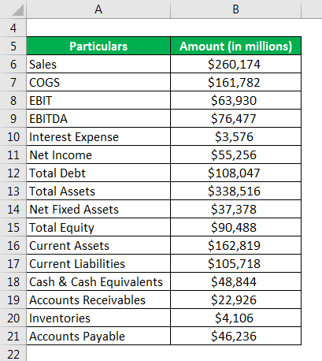

**Solution:**

**Liquidity Ratios**

Current Ratio is calculated using the formula given below

**Current Ratio = Current Assets / Current Liabilities**

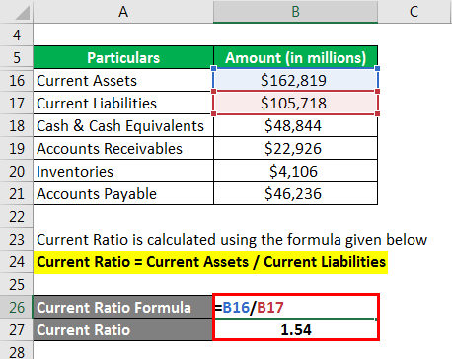

* Current Ratio = $162,819 million / $105,718 million
* Current Ratio = **1.54x**

Quick Ratio is calculated using the formula given below

**Quick Ratio = (Cash & Cash Equivalents + Accounts Receivables) / Current Liabilities**

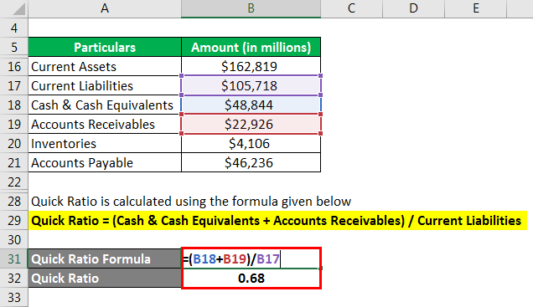

* Quick Ratio = ($48,844 million + $22,926 million) / $105,718 million
* Quick Ratio = **0.68x**

Cash Ratio is calculated using the formula given below

**Cash Ratio = Cash & Cash Equivalents / Current Liabilities**

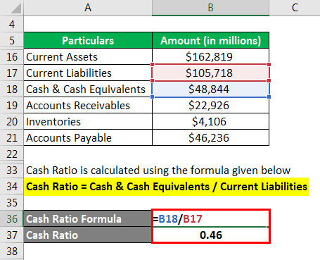

* Cash Ratio=  $48,844 million / $105,718 million
* Cash Ratio = **0.46x**

**Solvency Ratios**

Debt to Equity Ratio is calculated using the formula given below

**Debt to Equity Ratio = Total Debt / Total Equity**

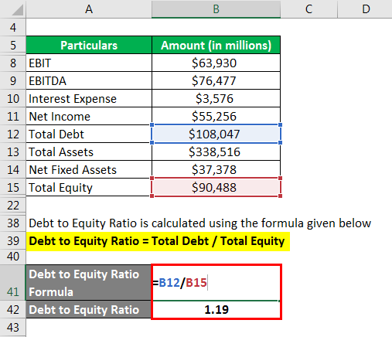

* Debt to Equity Ratio = $108,047 million / $90,488 million
* Debt to Equity Ratio = **1.19x**

Debt Ratio is calculated using the formula given below

**Debt Ratio = Total Debt / Total Assets**

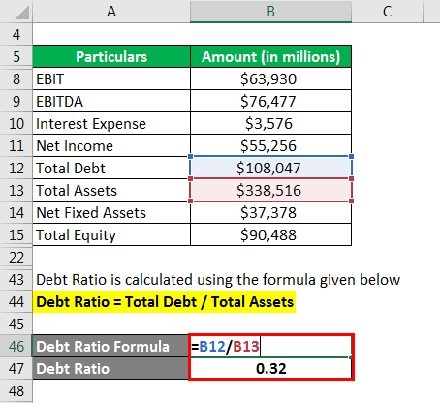

* Debt Ratio = $108,047 million / $338,516 million
* Debt Ratio = **0.32x**

Interest Coverage Ratio is calculated using the formula given below

**Interest Coverage Ratio = EBITDA / Interest Expense**

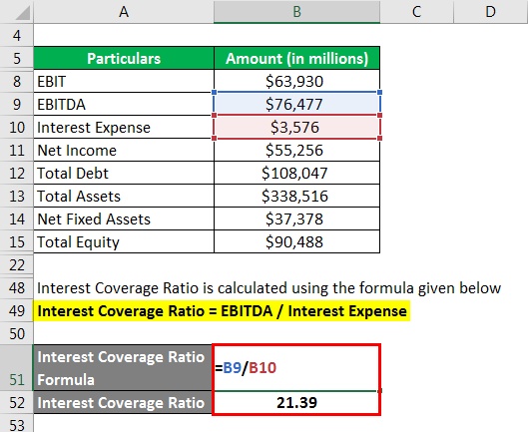

* Interest Coverage Ratio = $76,477 million / $3,576 million
* Interest Coverage Ratio = **21.39x**

**Efficiency Ratios**

Receivables Turnover Ratio is calculated using the formula given below

**Receivables Turnover Ratio**=**Sales / Accounts Receivable**

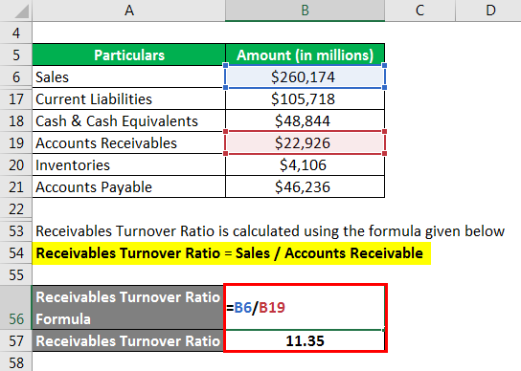

* Receivables Turnover Ratio = $260,174 million / $22,926 million
* Receivables Turnover Ratio = **11.35x**

Inventory Turnover Ratio is calculated using the formula given below

**Inventory Turnover Ratio = COGS / Inventories**

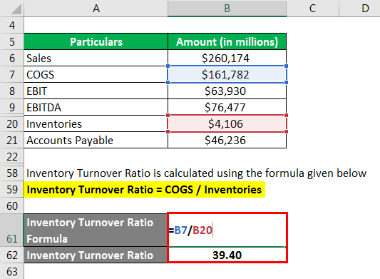

* Inventory Turnover Ratio = $161,782 million / $4,106 million
* Inventory Turnover Ratio = **39.40x**

Payable Turnover Ratio is calculated using the formula given below

**Payable Turnover Ratio = COGS / Accounts Payable**

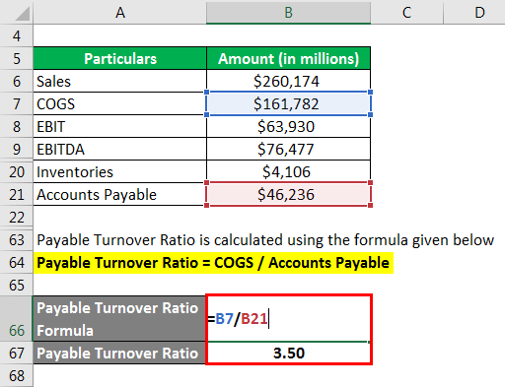

* Payable Turnover Ratio = $161,782 million / $46,236 million
* Payable Turnover Ratio = **3.50x**

Asset Turnover Ratio is calculated using the formula given below

**Asset Turnover Ratio = Sales / Total Assets**

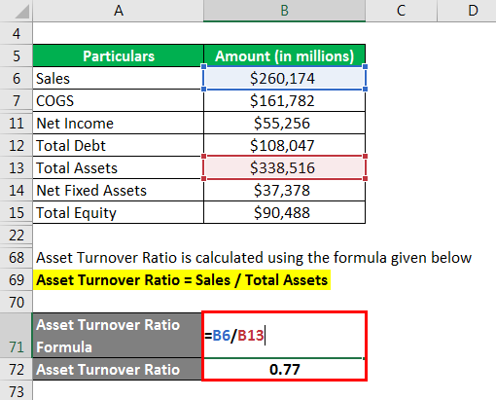

* Asset Turnover Ratio = $260,174 million / $338,516 million
* Asset Turnover Ratio = **0.77x**

Net Fixed Asset Turnover Ratio is calculated using the formula given below

**Net Fixed Asset Turnover Ratio = Sales / Net Fixed Assets**

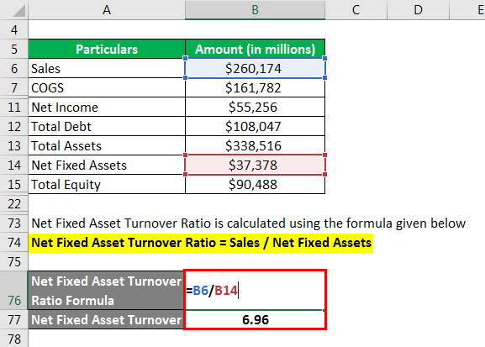

* Net Fixed Asset Turnover Ratio = $260,174 million / $37,378 million
* Net Fixed Asset Turnover Ratio = **6.96x**

Equity Turnover Ratio is calculated using the formula given below

**Equity Turnover Ratio = Sales / Total Equity**

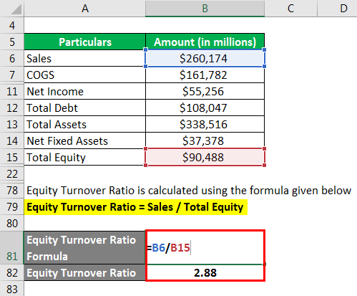

* Equity Turnover Ratio = $260,174 million / $90,488 million
* Equity Turnover Ratio = **2.88x**

**Profitability Ratios**

Gross Margin is calculated using the formula given below

**Gross Margin = (Sales – COGS) / Sales**

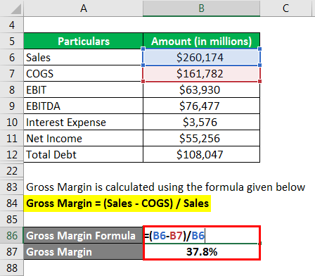

* Gross Margin = ($260,174 million – $161,782 million) / $260,174 million
* Gross Margin = **37.8%**

Operating Profit Margin is calculated using the formula given below

**Operating Profit Margin = EBIT / Sales**

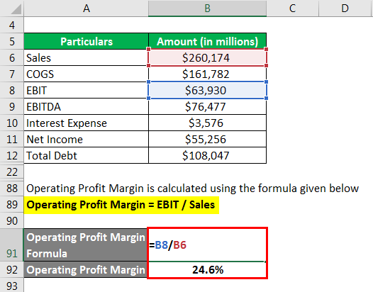

* Operating Profit Margin = $63,930 million / $260,174 million
* Operating Profit Margin = **24.6%**

Net Margin is calculated using the formula given below

**Net Margin = Net income / Sales**

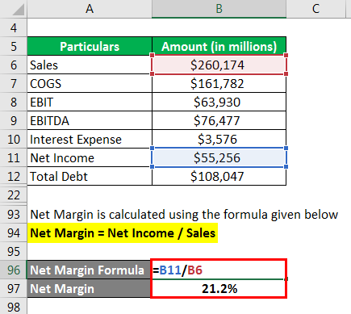

* Net Margin = $55,256 million / $260,174 million
* Net Margin = **21.2%**

Return on Total Asset (ROA) is calculated using the formula given below

**Return on Total Asset (ROA) = EBIT / Total Assets**

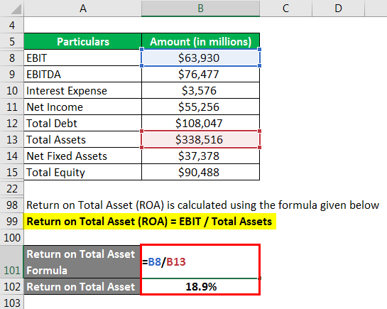

* Return on Total Asset (ROA) = $63,930 million / $338,516 million
* Return on Total Asset (ROA) = **18.9%**

Return on Total Equity (ROE) is calculated using the formula given below

**Return on Total Equity (ROE) = Net Income / Total Equity**

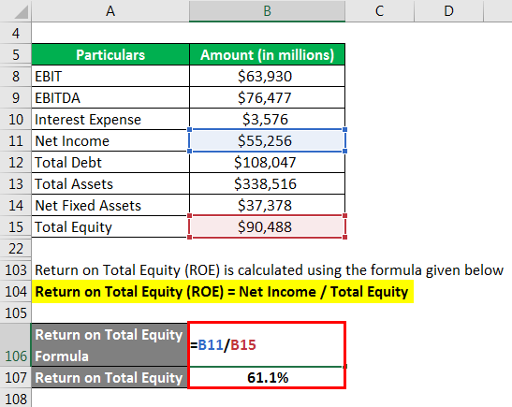

* Return on Total Equity (ROE) = $55,256 million / $90,488 million
* Return on Total Equity (ROE) = **61.1%**

**Source Link:** [Apple Inc. Balance Sheet](https://s2.q4cdn.com/470004039/files/doc_financials/2019/ar/_10-K-2019-(As-Filed).pdf)

**Relevance and Use of Reserve Ratio Formula**

One of the major uses of ratio analysis is that it makes it easier and simpler to compare companies with different scale of operations. Further, it also simplifies the analysis of the financial statements and helps in identifying deviation in historical trends.

CONCLUSION

The business has been growing into losses for the estimated time period.

**References**

Barkham, R Gudgin, G Hart, M and Hanvey, E (1996) ‘*The Determinants of Small Firm Growth - An Inter-Regional Study in the UK: 1986-90’*, Jessica Kingsley, London.

Brockhaus R H Sr (1994) Entrepreneurship and Family Business Research: Comparisons, Critique and Lessons, *Entrepreneurship Theory and Practice*, 19, 25-38.

Buzzell, R D and Gale, R (1987) *'The PIMS Principles - Linking Strategy to Performance'*, Free Press, New York.

Cambridge Small Business Research Centre (1992) *‘The State of British Enterprise: Growth, Innovation and Competitive Advantage in Small and Medium-Sized Firms’*, University of Cambridge, Small Business Research Centre.

Carroll, C (1985) *'Building Ireland's Business: Perspectives from PIMS'*, Irish Management Institute, Dublin.

Conyon, M and Machin, S (1991) ‘Profit Margins in UK Manufacturing’, *Journal of Industrial Economics*, XXXIX, 4, 369-382.

Cubbin, J and Leech, D (1986) ‘Growth v Profit Maximisation – A Simultaneous Equation Approach to Testing the Marris Model’, Managerial and Decision Economics, 7, 2, 123-131.

Deakins, D Majmudar, M and Paddison, A (1996) ‘Success Factors For Ethnic Minorities in Britain’, paper presented at the ISBA Policy and Research Conference, Birmingham.

Dickson, K Coles, A-M and Woods, A (1996) ‘Inspiration or Infringement: Copyright Protection for Small Textile Design Firms’, paper presented at the ISBA Policy and Research Conference, Birmingham.

Dunne, P and Hughes, A (1994) 'Age, Size, Growth and Survival: UK Companies in the 1980s', *Journal of Industrial Economics*, XLII, 2, pp 115-140.

Gallagher, C C Daly, M J and Thomason, J C (1991) 'The Growth of UK Companies and their Contribution to Job Generation: 1985-87', *Small Business Economics*, 3, 269-286.

Geroski, P (1990) ‘Innovation, technological Opportunity and Market Structure’, *Oxford Economic Papers*, 42, 586-602.

Geroski, P Machin, S and VanReenen, J (1993) ‘The Profitability of Innovating Firms’, Rand Journal of Economics, 24, 2, 98-211.

Greene, W H (1993) *‘Econometric Analysis’*, Macmillan, New York.

Gudgin, G Scott, R Hanvey, E and Hart, M (1995) ‘The Role of Small Firms in Employment Growth in Ireland, North and South’, in J Bradley (ed) ‘*The Two Economies of Ireland’*, Oak Tree Press, Dublin.

Harris, R I D and Trainor, M (1995) ‘Innovations and R&D in Northern Ireland Manufacturing: A Schumpeterian Approach’, *Regional Studies*, 29, 593-604.

Hakim, C (1989) ‘Identifying Fast Growth Small Firms’, *Employment Gazette*, Jan, 29-41.

Hewitt Dundas, N Roper, S and McFerran, B (1996) ‘Profitability and Growth in Ireland’s Small Firms - A North/South Comparison’, Working Paper 19, Northern Ireland Economic Research Centre, Belfast.

Hewitt-Dundas, N Roper, S (1997) ‘Overcoming Customer Dependency: A Case Study of Small Consumer Food Companies in Northern Ireland’, Working Paper 33, Northern Ireland Economic Research Centre, Belfast.

Jovanovic, B (1982) 'Selection and Evolution of Industry', *Econometrica*, 50, 3, 649-670.

Kallenberg, A L and Leicht, K T (1991) ‘Gender and Organisational Performance: Determinants of Small Business Success and Survival’, *Academy of Management Journal*, 34, 1, 136-61.

Keogh, W Jack, S Bower, D J and Crabtree, E (1996) ‘Innovation and Internationalisation Strategies of Small, Technology Based Firms in the UK Oil and Gas Industry’, paper presented at the ISBA Policy and Research Conference, Birmingham.

Kinsella, R P et al (1993) ‘*Fast Growth Small Firms and Selectivity*, Irish Management Institute, Dublin.

Love J H Ashcroft, B and Dunlop, S (1996) ‘Corporate Structure, Ownership and the Likelihood of Innovation’, *Applied Economics*, 28.

Lucas, R E (1978) 'On the Size Distribution of Business Firms', *Bell Journal of Economics*, 9, 508-523.

Mc Ferran, B Hewitt-Dundas, M N and Roper, S (1996) ‘*Performance Benchmarks for Developing Firms’*, The CAM Project, NIERC, Belfast.

Macrae, D J R (1991) ‘Characteristics of High and Low Growth SMEs’, paper presented at European Small Business Seminar, Barcelona.